Convert Units
1. Convert to feet: 132 inches
2. Convert to quarts: 24 pints

3. Convert to yards: 6 feet

4. Convert to cups: 56 ounces
5. Convert to yards: 36 inches
6. Convert 12 miles to yards.
7. Convert to pounds: 3 tons
8. Convert to ounces: 6 pounds
9. Convert to gallons: 32 quarts
10. Convert to ounces: 3 pounds
11. Convert to pints: 20 cups
12. Convert to gallons: 24 quarts
13. Convert to pounds: 48 ounces
14. Convert to quarts: 16 pints
15. Convert to pounds: 64 ounces
16. Convert to quarts: 4 pints
17. Convert to cups: 32 ounces
18. Convert to quarts: 10 pints
19. Convert 5,280 yards to miles.
20. Convert to quarts: 14 pints
21. Convert to pounds: 96 ounces

22. Convert to quarts: 8 pints
23. Convert to pounds: 64 ounces
24. Convert 7,040 yards to miles.
25. Convert to quarts: 18 pints
26. Convert to ounces: 2 pounds
27. Convert to feet: 144 inches
28. Convert to inches: 2 yards
29. Convert to ounces: 4 pounds
30. Convert 21,120 yards to miles.
31. Convert to tons: 8,000 pounds
32. Convert to quarts: 20 pints
33. Convert to inches: 2 feet
34. Convert to ounces: 5 pounds
35. Convert to pints: 10 cups
36. Convert to quarts: 22 pints
37. Convert 6 miles to yards.
38. Convert to feet: 5 yards
39. Convert to quarts: 6 pints
40. Convert to pounds: 32 ounces

Coordinate Plane
Write the coordinates for each point.
  1.
    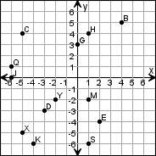
      K | _______
      Y | _______
      G | _______
      J | _______
      D | _______
  2.
    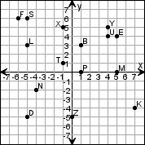
      Z | _______
      D | _______
      K | _______
      L | _______
      M | _______
Find each ordered pair. Write the letter for the point named by the ordered pair.
  3.
    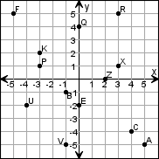
      (-5, 5) | _______
      (4, -4) | _______
      (2, 0) | _______
      (-3, 2) | _______
      (-4, -2) | _______
  4.
    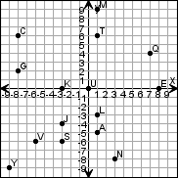
      (0, 0) | _______
      (-3, -4) | _______
      (3, -8) | _______
      (7, 4) | _______
      (-8, 6) | _______
Draw the ordered points on the grid. Label each point.
  5.
    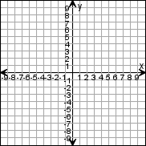 |  | U (-2, -5)  Q (-7, 0)  G (-7, -1)  B (-5, 7)  L (-6, -3)  R (0, -1)
  6.
    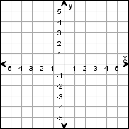 |  | Z (-3, 4)  Y (0, 2)  Q (-2, -4)  M (0, 3)  U (2, 2)  B (3, 0)

Quiz: 2-dimensional and 3-dimensional shapes:
- Name the 3-d shape which has 2 triangular faces and 3 rectangular faces?
- How many faces, vertices and edges does a pentagonal pyramid have?
- Meghna is building a 3-d object. It has 6 faces and all the faces are congruent. Which is the shape of the object Meghna is making?
- Choose the figure in which all points are the same from its center.
Square pyramid Sphere Cone Cube
- Name the 3-d shape having 5 vertices.
- Name the shape having 2 parallel bases and no edges.
- How many more faces does a octagonal pyramid have than triangular prism?
- What is the difference between a prism and pyramid? Draw any one type of prism and a pyramid.
- Which of the following statements describes parallelogram?
 | A. | The shape has parallel but not perpendicular lines.
 | B. | The shape has neither parallel nor perpendicular lines.
 | C. | The shape has perpendicular but not parallel lines.
 | D. | The shape has both parallel and perpendicular lines.
- Look at the map of train tracks below.
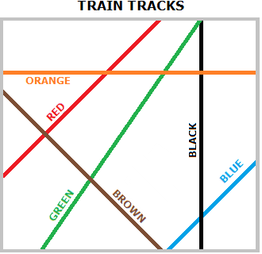

- Which tracks appear to be perpendicular to each other?

- Write true or false.
- All parallelograms are rectangles.
- All rectangles are parallelograms.
- All squares are rhombus but all rhombuses are not squares.
- All squares are not rectangles.

- Which of the following statements describes the shape pentagon?
 | A. | The shape has parallel but not perpendicular lines.
 | B. | The shape has neither parallel nor perpendicular lines.
 | C. | The shape has both parallel and perpendicular lines.
 | D. | The shape has perpendicular but not parallel lines.  - What do you think which 2-d shapes are used to make  Cylinder  Square pyramid  Triangular pyramid  Triangular prism  - How can you make 8 equal triangles in a rectangle?  - How can you make 4 equal triangles using 6 matchsticks?

