Percentage
1.
What percent of the figure is shaded yellow?

2.
What percent of the figure is shaded yellow?

3.
What percent of the figure is shaded yellow?

4.
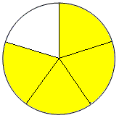
What percent of the figure is shaded yellow?

5.
What percent of the figure is shaded yellow?

6.
What percent of the figure is shaded yellow?

7.
What percent of the figure is shaded yellow?
8. Megan's Muffins sold 40% of their blueberry muffins within the first two hours they were open. What fraction is equivalent to 40%?

9.
What percent of the figure is shaded yellow?

10.
What percent of the figure is shaded yellow?

11.
What percent of the figure is shaded yellow?

12.
What percent of the figure is shaded yellow?

13.
What percent of the figure is shaded yellow?

14.
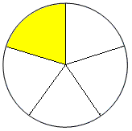What percent of the figure is shaded yellow?

15. By 4:30 P.M., Justin had finished 35% of his homework. What fractional part of his homework has Justin NOT finished yet?

16. Harry went apple picking with his family. Of the apples they picked, 64% of them were red. What fraction is equivalent to 64%?

17.
What percent of the figure is shaded yellow?

18.
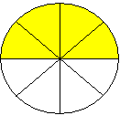What percent of the figure is shaded yellow?
19. Betty sold 27 out of the 90 quilts she made. What percent of her quilts did Betty sell?

20.
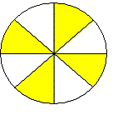What percent of the figure is shaded yellow?
21. What percent of the figure is shaded yellow?

22.
What percent of the figure is shaded yellow?

23.
What percent of the figure is shaded yellow?

24.
What percent of the figure is shaded yellow?

25. What percent of the figure is shaded yellow?

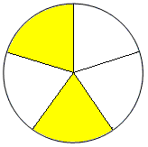
26.
What percent of the figure is shaded yellow?

27.
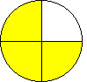
What percent of the figure is shaded yellow?

28.
What percent of the figure is shaded yellow?

29.
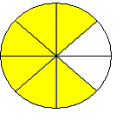
What percent of the figure is shaded yellow?

30.
What percent of the figure is shaded yellow?

Find the percent of each number. Round your answer to the nearest tenth.
  1. | 39% of 62
  2. | 44% of 41
  3. | 1% of 69
  4. | 89% of 1
  5. | 46% of 37
  6. | 27% of 95
  7. | 64% of 12
  8. | 14% of 3
  9. | 25% of 24
  10. | 90% of 60
  11. | 85% of 26
  12. | 114% of 55
  13. | 191% of 11
  14. | 157% of 7
  15. | 146% of 65

